1.The Operations team would like to know which countries we currently operate in and which country now has the most stores. Perform a query on the database to get the information, it should return the following information:

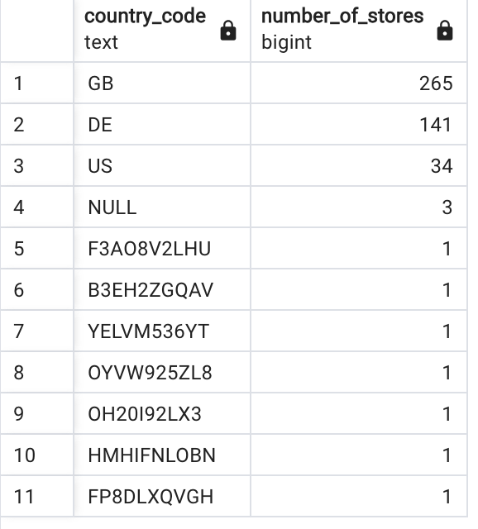

SELECT country_code, COUNT(*) AS number_of_stores
FROM dim_store_details
GROUP BY country_code
ORDER BY number_of_stores DESC;

The business stakeholders would like to know which locations currently have the most stores.
They would like to close some stores before opening more in other locations.
Find out which locations have the most stores currently. The query should return the following:

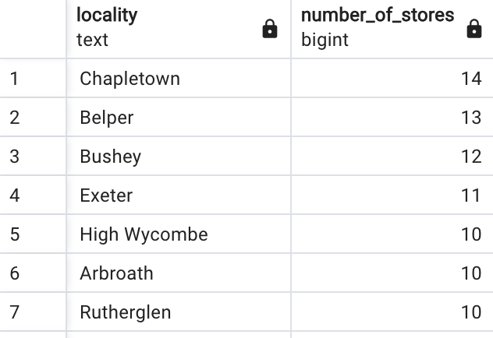

SELECT locality, COUNT(*) AS number_of_stores
FROM dim_store_details
GROUP BY locality
ORDER BY number_of_stores DESC;
Query the database to find out which months have produced the most sales. The query should return the following information:

